**Hands_On-2(Student Management Portal named StudentApp)**

**Step 1: Create React App**

In **VS Code terminal**, type:

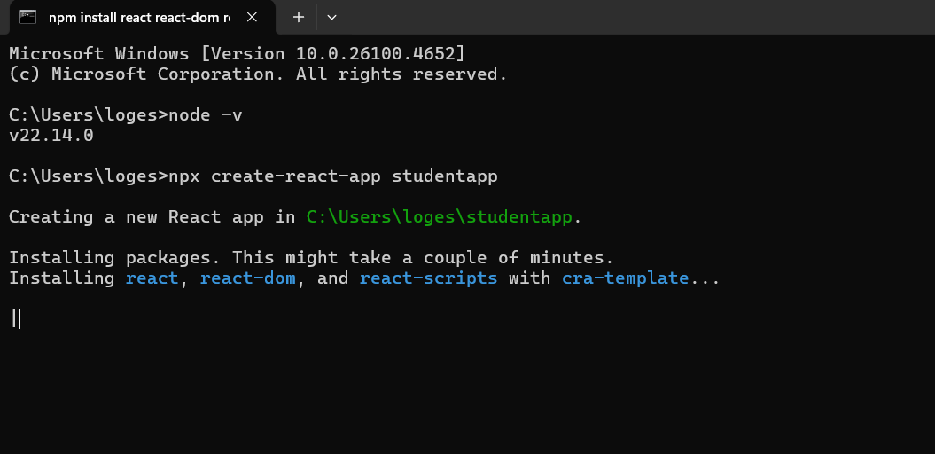

**Step 2: Create Home.js Component**

Inside Components, create Home.js:

import React, { Component } from 'react';

class Home extends Component {

render() {

return (

<div>

<h2>Welcome to the Home page of Student Management Portal</h2>

</div>

);

}

}

export default Home;

**Step 4: Create About.js Component**

import React, { Component } from 'react';

class About extends Component {

render() {

return (

<div>

<h2>Welcome to the About page of the Student Management Portal</h2>

</div>

);

}

}

export default About;

**Step 5: Create Contact.js Component**

import React, { Component } from 'react';

class Contact extends Component {

render() {

return (

<div>

<h2>Welcome to the Contact page of the Student Management Portal</h2>

</div>

);

}

}

export default Contact;

**Step 6: Edit App.js to Render All Components**

import React from 'react';

import './App.css';

import Home from './Components/Home';

import About from './Components/About';

import Contact from './Components/Contact';

function App() {

return (

<div className="App">

<Home />

<About />

<Contact />

</div>

);

}

export default App;

**Step 7: Run the App**

npm start

**Step 8: View in Browser**

